|  |  |
| --- | --- |
| Student number | 20013435 |
| Main text body word count | <<insert your main text body word count here >> |
|  |  |
|  |  |
| **Reflective abstract (up to 150 words)**  Please help the marker give you useful, personally-tailored, feedback by completing the sections below. Nothing you write here will adversely affect your mark. | |
| What mark do you anticipate your essay will achieve? | << insert here the mark you anticipate your essay will achieve >> |
| What do you think you did well in the writing of this essay? | << insert here aspects of your essay that you think went well >> |
| What aspects of your essay do you think may need improvement? | << insert aspects of your essay that you think may need improvement here >> |
| What areas of feedback would be most helpful for you? | << indicate what feedback would be most helpful for you here >> |

PART I << CRITICAL REVIEW >> (not less than 500 words)

I .1 INTRODUCTION

<< In this section, state the purpose and scope of the critical review, and include a little background on the choice of enterprise systems modelling framework >>

1.2 EVALUATION CRITERIA

<< In this section, explain and specify the evaluation criteria to be applied to the chosen modelling framework, e.g. cost, capabilities, performance, usability etc. >>

1.3 EVIDENCE (WITH EXAMPLE ILLUSTRATIONS) AND ANALYSIS

<< In this section, provide evidence of modelling framework performance in enterprise systems modelling. For example, provide examples from the literature and illustrations of enterprise systems models taken from the UWEFlix case study such as:

* Requirements models (use cases or user stories)
* Requirements specifications
* Business <<type>> models
* Interface and service models
* Component sequence diagrams
* Architectural models (both service and component based)

For the example illustrations, analyse the evidence by applying the evaluation criteria where appropriate.

Make sure you **include** the **modelling diagrams** in **Appendix B not in this section** while you cite each within the text you include in this section>>

1.4 CONCLUSIONS

<< Draw upon the evidence and analysis presented in the previous section, together with any relevant and useful sources, to derive conclusion(s) >>

PART II << REFLECTIVE REPORT >> (not less than 300 words)

2 .1 INTRODUCTION

<< In this section, state the purpose and scope of the reflective report, and include a little background on the teamwork you practiced >>

2.2 REFLECTIONS

<< In this section, identify and explain what went well, what went wrong while you developed and implemented your software. Try to draw attention on your good practices and issues that you faced and resolved. You may like to go with sub-headlines if you like. >>

2.3 CONCLUSIONS

<< Draw upon the evidence and analysis presented in the previous section, together with any relevant and useful sources, to derive conclusion(s) >>

REFERENCES

<< List references cited in both parts of the report using UWE Harvard style >>

Appendix A

<< Provide the GitHub link of your code >>

Appendix B

<< Insert all modelling diagrams in this section. Make sure each figure has a figure title with which you cite each within the text body >>

Figure – Use Case diagram

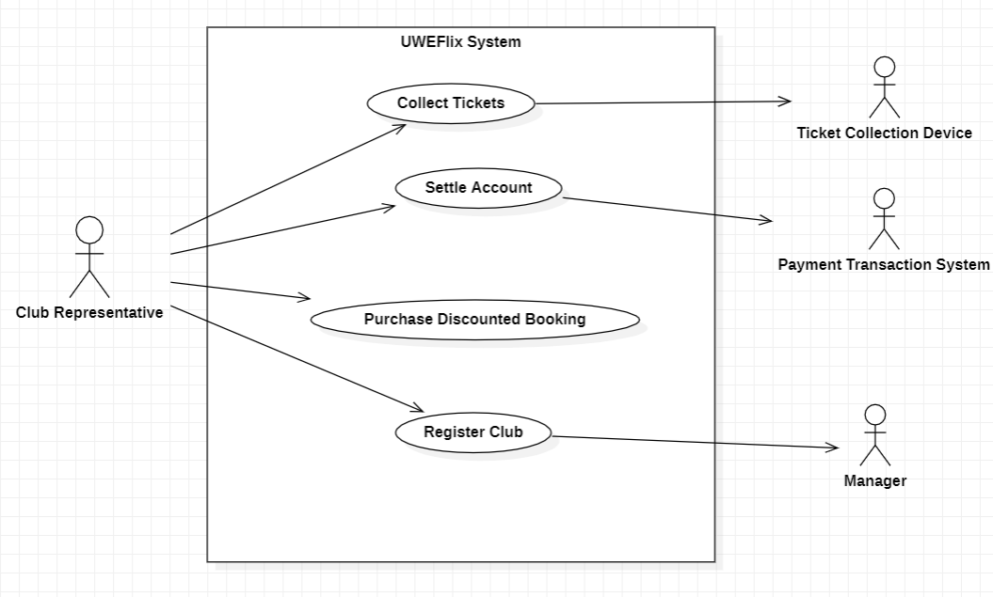

Figure – Interface Diagram

